Nuclear Physics Escape Room User Guide –
Digital Props

Contents
Audience 2
Scenario 2
Preamble 2
Set Up Instructions 3
Delivery 4
Worked Solutions 5
Common Pitfalls 8
Resources 9

Message from Creator

Hello, my name is Reiss Luke, I designed and developed this Nuclear Physics Escape Room as part of my master’s project in Physics at Newcastle University. In early 2022 I ran this and another escape room which I developed, in several schools with over 250 pupil engagements. Upon the completion of my degree, I am making all the resources free to everyone and have set out a comprehensive plan of how to run the session and all the resources you need. If you are local to Newcastle University, you may wish to contact Newcastle University Physics Outreach at physics.outreach@newcastle.ac.uk, who may be able to run the session for your group. To monitor the use and improve the physics escape room for future use, it would be greatly appreciated if after using the resources if you could fill out a short questionnaire, following the QR code on the website.

Thanks,
Reiss

Audience

This nuclear physics escape room utilises KS3 Physics knowledge and problem-solving skills to crack a code and save the day! The session is best suited to;

Group Age: Year 9/10
Group Size: Around 10/15 (ideal for a physics/STEM club)

Scenario

The Angstrom Nuclear Power Plant (ANPP) is under the control of the new corporate director, Mary Hewson. Dr Werner Heisenberg the lead nuclear physicist at ANPP has noticed the new director has been acting very strange over the last few months, slowly removing members of staff from the plant. In recent times the director’s actions have become odder and odder, this has led to Dr Heisenberg preparing for his expected removal from the plant! By invitation of Dr H you visit the ANPP, where he is nowhere to be seen and only a skeleton crew of workers remain. Mid way through your visit, the warning system kicks in! Lights are flashing and sirens howl throughout the plant. A video of Dr Heisenberg starts playing… With the impending doom of a nuclear meltdown imminent, you must rely on your physics knowledge to decode the trail of clues left behind by Dr H, in time to stop the meltdown and relinquish control from the director! You have 40 minutes to become heroes!

Preamble

To make this escape room as inclusive as possible, there are two options;
- Physical Props
- Digital Props

This booklet contains the relevant information for the use of digital props, for information on the use of physical props please see the Nuclear Physics Escape Room User Guide – Physical Props.

The nuclear escape room takes minimal effort once the initial preparations are made!

Set Up Instructions

- Printing and Cutting Resources. All the resources (see Resources) need to be printed and cut to size, (for repeated use, laminating is recommended, this also allows the group to write on the clues with dry wipe markers).
- Distribute the Resources.
Put to one side the;
- Receipt
- Cipher Decoders
- Driver’s Licence
- Jigsaw
- Credit Card
- Concert Ticket Clue

These clues are locked until the correct answers are given for the virtual locked boxes. The remaining resources can then be randomly distributed around the room, except the 8 Answer Boxes, these are placed randomly on a table at the front.
Virtual Locked Boxes. From the resources you placed to one side, you now need to separate them into the correct virtual locked box and keep them away from the group. I suggest that you keep 4 plastic wallets (or something similar) label each of the wallets, and then place the corresponding resources in them.

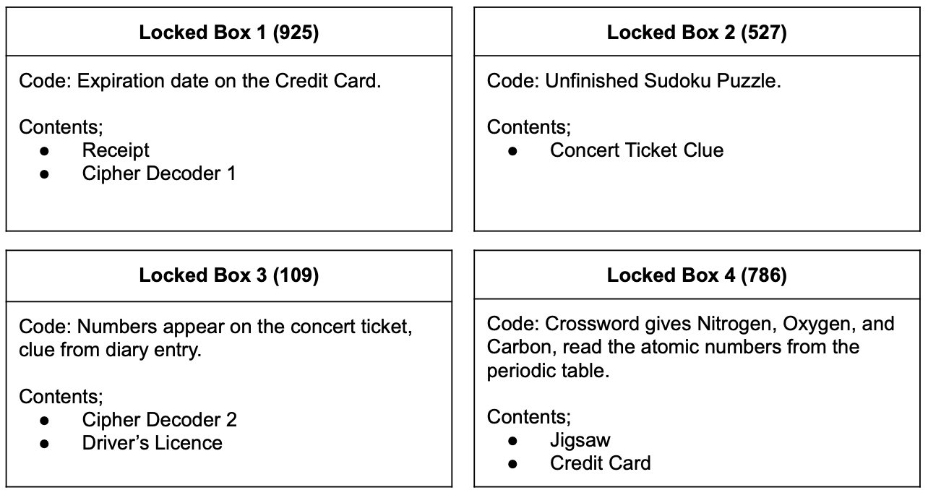

Delivery

The escape room is designed to be hands on and interactive, once the setup is complete there is minimal leader involvement. There is an optional presentation which introduces nuclear physics to begin, and some closing remarks, this rounds the activity off nicely tying everything back to the physics but is not integral to the activity.

An Introduction to Nuclear Physics - This provides a nice introduction to the physics of nuclear fission and nuclear power plants to GCSE level. In addition, there are two slides which lay out the activity to the group. The presentation contains a video of Dr Heisenberg which sets the scene nicely and has a couple of slides to end the session.

Nuclear Escape Room Virtual Boxes – When the group believes they have an answer to one of the locked boxes, they press the hyperlinked numbers to enter their code. If they successfully input the code, this will be indicated on screen and will prompt you to provide them with the contents of the virtual locked box they have just unlocked, which you have placed to one side.

Nuclear Escape Room Answer Checker - This is a presentation which allows the group to input their answers to check if they have the correct code. I recommend this being used once the group has a code, they believe to be correct, to prevent guessing, making sure they have solved all the problems.

All PowerPoints are included with this pack, and have speaker notes to aid delivery.

Recommended Timetable

Activity | Duration | Notes
An Introduction to Nuclear Physics (slides 1-7) | 10 minutes | Instructor lead
Escape Room | 40 Minutes
Nuclear Escape Room Virtual Boxes | When the group thinks they have the correct locked box codes
Nuclear Escape Room Answer Checker | When the group thinks they have the correct code | Gather the group at the front, around the answer cards
An Introduction to Nuclear Physics (slides 8-10) | 5 minutes | Instructor lead

Notes
- The group will not know which code unlocks which box, so will have to use trial and error, however, in the spirit of the escape room don’t just guess the codes.
- If the group is struggling, and they are running short on time feel free to provide them with hints, however from experience the less hints the better the student experience.
- Encourage the group to write their answer on the corresponding answer cards.
- When all the answer cards have numbers on them, gather the group around the front and ask if they have noticed anything about the answer cards. Once the connection is made to the highlighted letters, I write on a whiteboard the 8 letters and corresponding numbers and let them try to determine the pattern to get the order.
Worked Solutions

Mercury = 1  - Jigsaw | Jigsaw of the atomic structure of Oxygen and Neon atoms.  - Count electrons (8 = Oxygen, 10 = Neon)  - Find in Periodic Table  - Chemical symbols spell O Ne  - Answer is therefore 1
Venus = 6  - Circuit Diagram | Using the sharing of current across a parallel circuit, the reading at the ammeter is given by adding the currents shown on the circuit diagram.  I_{Tot} = I₁ + I₂ + I₃ = 2 + 2 + 2 = 6
Earth = 8  - Energy Fact Sheet | Using assumed knowledge the clues describe a type of energy resource, the answers can be written on the card.  - N U C L E A R  - W I N D  - G E O T H E R M A L  - H Y D R O E L E C T R I C  - T I D A L  Once they have all five answers, the highlighted letters are noticed, which spell eight providing the answer.
Mars = 3  - Combustion Data Sheet  Uses;  - Scrabble Tiles | Using assumed knowledge, the write down the three components to the combustion triangle (fuel, oxygen, and heat). The scrabble tiles are then used to spell the words and the scrabble values of the corresponding letter can be written on the sheet. Using the scrabble tile values, the problem becomes simple arithmetic.  - F U E L = 4 + 1 + 1 + 1 = 7  - O X Y G E N = 1 + 8 + 4 + 2 + 1 + 1 = 17  - H E A T = 4 + 1 + 1 + 1 = 7  (2) - [(1) + (3)] = 17 - (7 + 7) = 17 - 14 = 3
Jupiter = 7  - Newspaper | After reading the newspaper article, they can determine the resultant force, using the numerical values in the article.  40 - 18 - 15 = 7
Saturn = 4  - Drivers Licence  Uses;  - Cipher  - Cipher Decoders | Cipher gives the key equation; speed = wavelength x frequency  However, they have no numerical values, these come from the driver’s licence, which provides;  - Frequency = 8  - Speed = 32  Rearranging the equation to get, $Wavelength=\frac{Speed}{Frequency}$  Substituting the values, you obtain; $\frac{32}{8}=4$
Uranus = 7  - Receipt | The receipt reads, “Price equals weight, mass?”  The price is 70, therefore the weight is 70.  Gravitational constant g = 10 (Assumed Knowledge)  Using the assumed knowledge that W = mg.  Mass = $\frac{70}{10}=7$
Neptune = 2  - Particle Models of Matter  Uses;  - Concert Tickets | Recognition of the different states of matter, the value for a solid, liquid, and gas are obtained from the concert ticket.  - Solid = 7  - Liquid = 8  - Gas = 9  Following the mathematical formula on the clue.  $$\frac{Solid+Gas}{Liquid}= ?$$  $$\frac{7+9}{8}= 2$$
Nuclear Shutdown Code = 16837472
Using the answer boxes, the group uses the highlighted letter on each card which is the first letter of each of the planets. Once the group has made the connection, they will be able to order their 8 answers correctly.

Solved Sudoku

5 | 3 | 4 | 6 | 7 | 8 | 9 | 1 | 2
6 | 7 | 2 | 1 | 9 | 5 | 3 | 4 | 8
1 | 9 | 8 | 3 | 4 | 2 | 5 | 6 | 7
8 | 5 | 9 | 7 | 6 | 1 | 4 | 2 | 3
4 | 2 | 6 | 8 | 5 | 3 | 7 | 9 | 1
7 | 1 | 3 | 9 | 2 | 4 | 8 | 5 | 6
9 | 6 | 1 | 5 | 3 | 7 | 2 | 8 | 4
2 | 8 | 7 | 4 | 1 | 9 | 6 | 3 | 5
3 | 4 | 5 | 2 | 8 | 6 | 1 | 7 | 9

Solved Jigsaw

Common Pitfalls

There are a couple of common pitfalls I have listed them below to help you help your delivery if your group also fall victim to them. Note, that these are here to help you as opposed to steering the group away from these.

- Particle Models of Matter – Incorrectly it is common to count the number of circles and use these number in mathematical equation, this results in $\frac{9+4}{10}=1.3$. This should be obviously wrong to the group, as we are looking for single digits.
- Jigsaw – The jigsaw is always finished, but it normally the last clue completed.
- Combustion Data Sheet – As this is reliant of assumed knowledge, sometime this proves a little tricky! In those circumstances it just requires a little time and asking them what you need to start a fire, also making the words from the scrabble tiles.
- Energy Fact Sheet – As this reliant of assumed knowledge, sometimes they are unfamiliar with hydroelectric and geothermal. The clue can still be answers as you know the answer must be 8 from nuclear and wind which are always well done.
- Receipt – Sometimes, impressively they quote the gravitational constant as the more accurate 9.81, this provides an answer of 7.1355… This should be obviously wrong to the group, as we are looking for single digits, just give the hint to round the gravitational constant to the nearest whole number.

Resources

Resources Checklist | \ \ | \ \ | \ \ | \ \ | \ \
Credit Card*
Driver’s Licence*
Newspaper Article
Periodic Table
Particle Models of Matter
Circuit Diagram
Receipt*
Concert Ticket
Solar System
Cipher Decoder*
Cipher
Sudoku Puzzle
Combustion Data Sheet
Energy Fact Sheet
Jigsaw*
8 Answer Boxes
Diary Entry
Crossword
Concert Ticket Clue

*These resources go into virtual locked boxes.

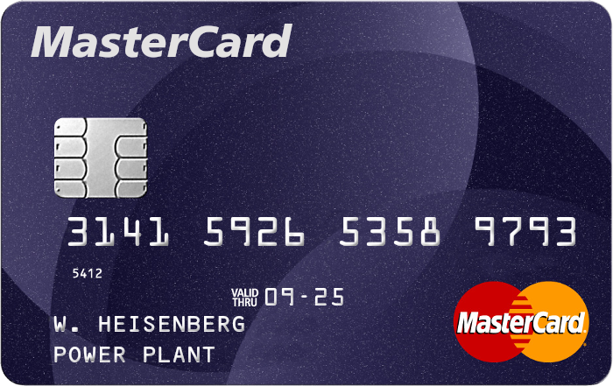

Credit Card

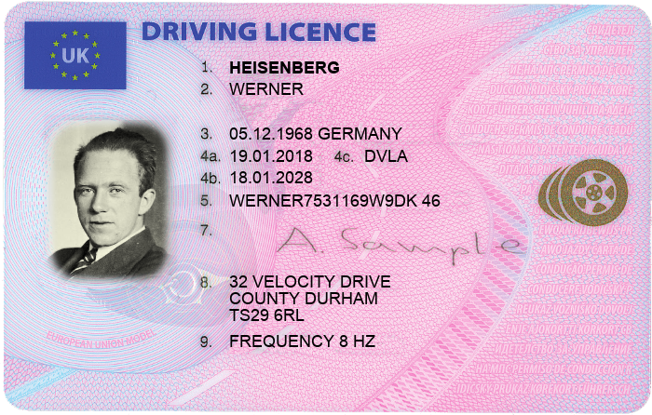

Driver’s Licence
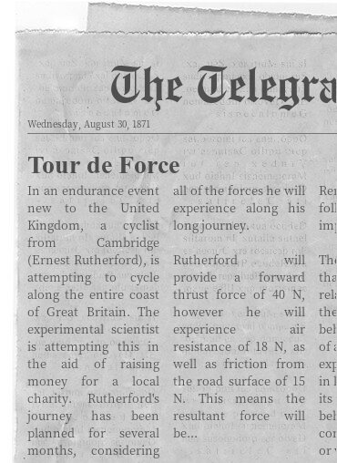

Newspaper
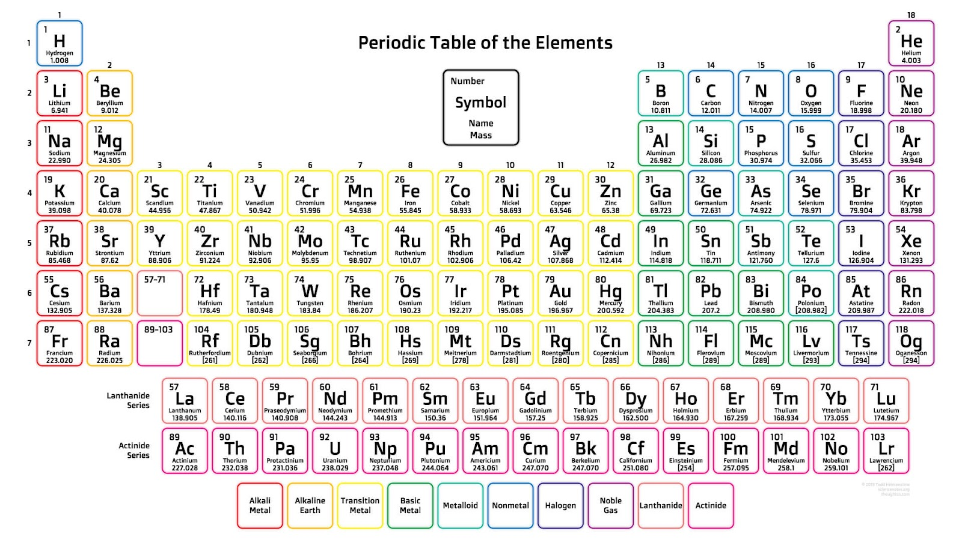

Periodic Table

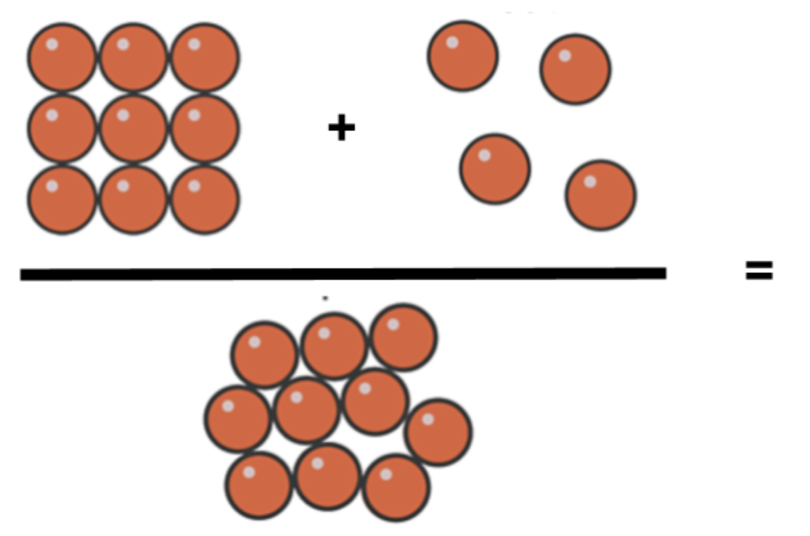

States Of Matter
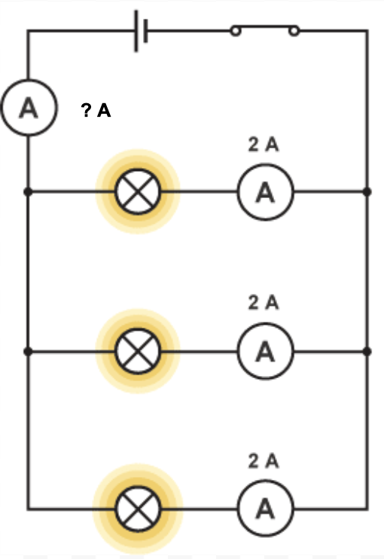

Circuit Diagram

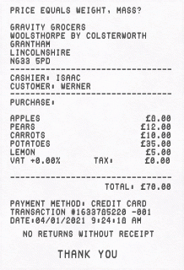

Receipt

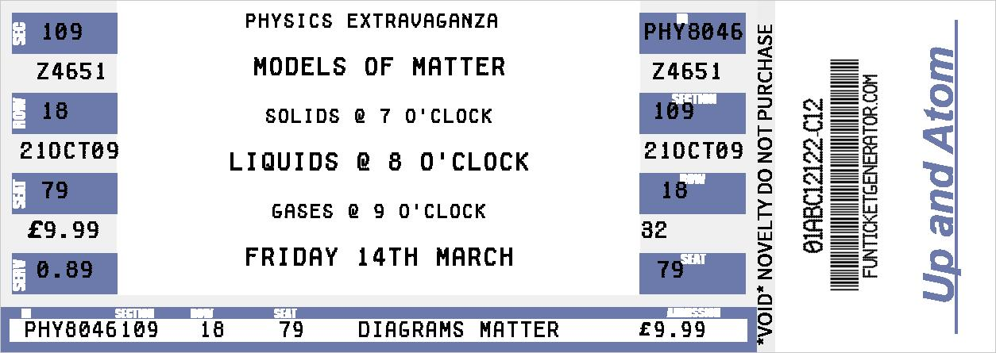

Concert Ticket
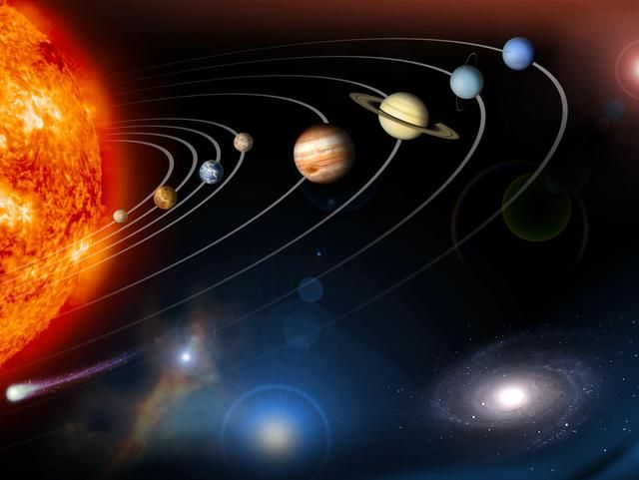

Solar System

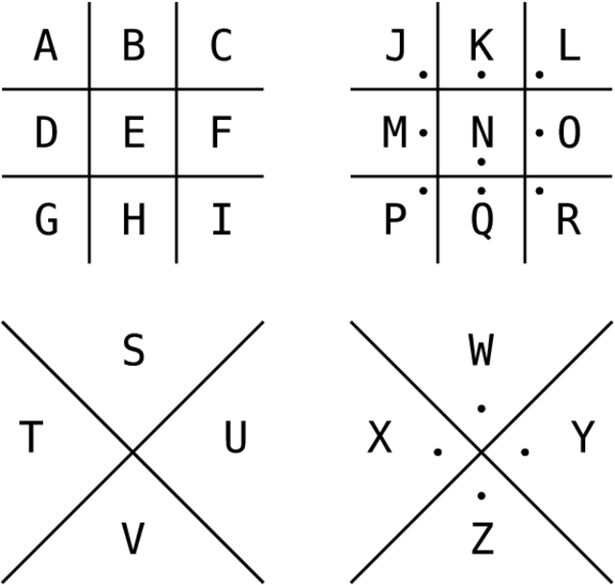

Cipher Decoders 1 and 2

Cipher

5 | 3 | 4 |  | 7 | 8 |  | 1 | 2
6 |  |  | 1 | 9 | 5 | 3 |  | 8
 | 9 | 8 |  | 4 |  |  | 6
8 | ^{1st} |  |  | 6 |  |  | ^{2nd} | 3
4 |  | 6 | 8 | 5 | 3 | 7 |  | 1
7 |  | 3 |  | 2 |  |  | 5 | 6
9 | 6 |  | 5 |  | ^{3rd} | 2 | 8
 |  | 7 | 4 | 1 | 9 | 6 |  | 5
3 | 4 |  |  | 8 |  |  | 7 | 9

Sudoku

Combustion Data Sheet

The fire triangle summarises the three things needed for combustion, if one of these things is removed the fire goes out. What are the three components of the fire triangle?

Use the scrabble tiles to spell out the answers.
The corresponding scrabble values will lead you to the answer.

Do NOT let the answer fall into the wrong hands!

(1) _ + _ + _ + _ = __
(2) _ + _ + _ + _ + _ + _ = __
(3) _ + _ + _ + _ = __

(2) - [(1) + (3)] = __

Energy Fact Sheet

Use your knowledge of renewable and non-renewable energy resources to find the correct answer.

(1) This non-renewable energy resource generates energy, through the splitting of heavy nuclei such as Uranium or Plutonium.

(2) This renewable energy resource is produced as a result of large movements of air, driven by the energy from the Sun.

(3) This renewable energy resource comes from hot water and steam from deep underground that is used to drive turbines.

(4) This renewable energy resource uses the kinetic energy in moving water, usually from behind a dam across a river valley.

(5) This renewable energy resource uses the kinetic energy in moving water, from behind a barrier built over a river estuary, from the water moving in and out of the river mouth each day.

- __ __ __ __ __ __ __
- __ __ __ __
- __ __ __ __ __ __ __ __ __ __
- __ __ __ __ __ __ __ __ __ __ __ __ __
- __ __ __ __ __

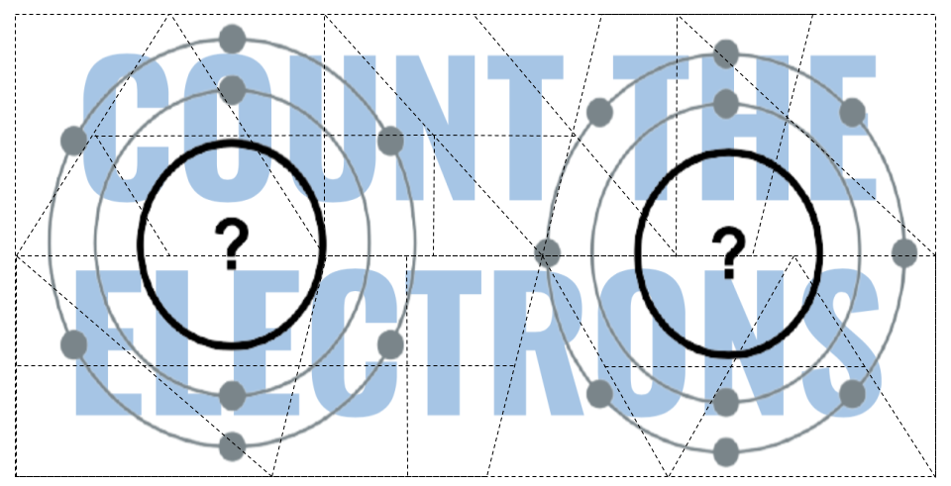
Jigsaw

Diary

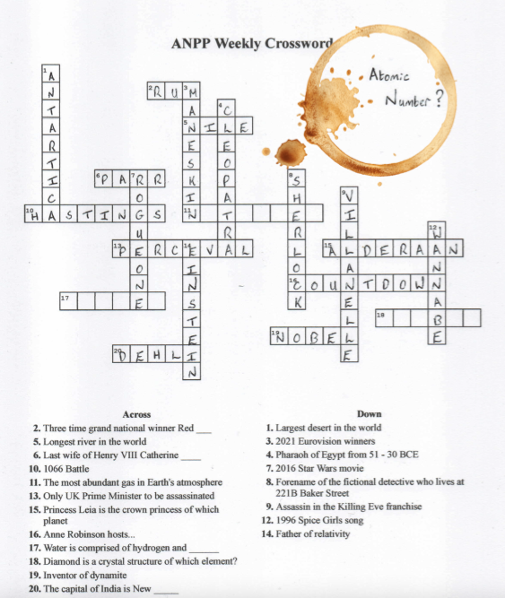

Crossword Atomic Number

__________
.
__________
.
.
.
.

Concert Ticket Clue

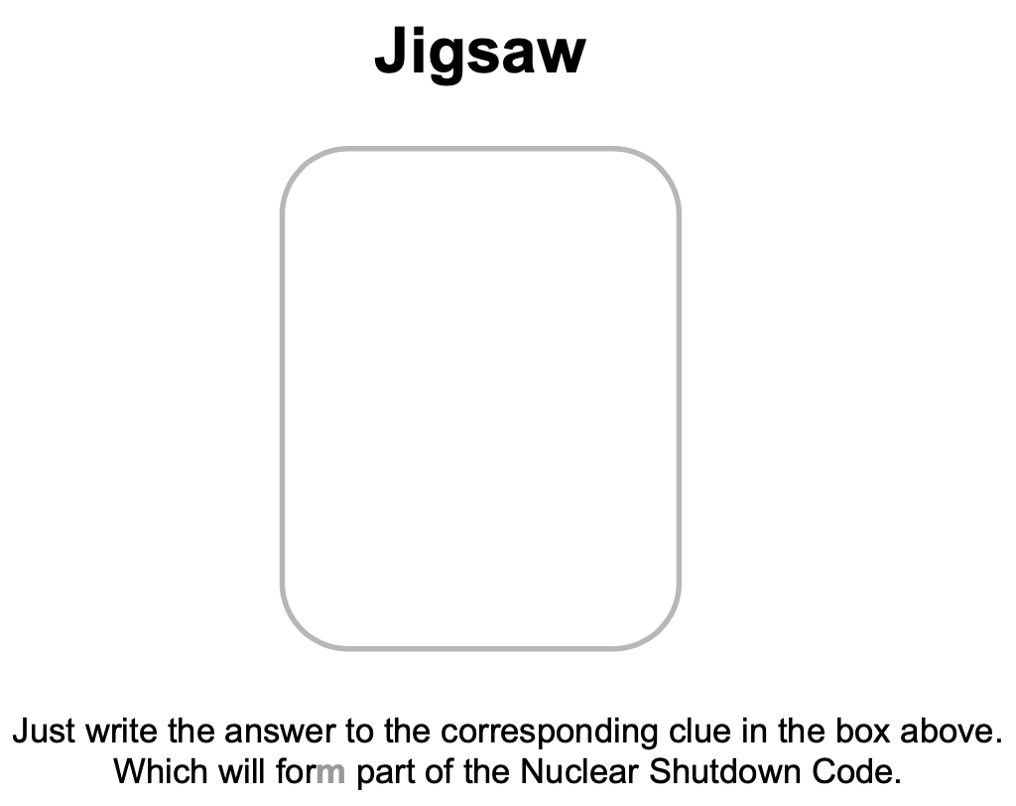

Answer Boxes
