Martian Physics Escape Room User Guide - Physical Props

Contents
Audience 2
Scenario 2
Preamble 2
Set Up Instructions 3
Delivery 4
Worked Solutions 5
Common Pitfalls 9
Resources 10
Physical Props Recommendations 25

Message from Creator

Hello, my name is Reiss Luke, I designed and developed this Martian Physics Escape Room as part of my master’s project in Physics at Newcastle University. In early 2022 I ran this and another escape room which I developed, in several schools with over 250 pupil engagements. Upon the completion of my degree, I am making all the resources free to everyone and have set out a comprehensive plan of how to run the session and all the resources you need. If you are local to Newcastle University, you may wish to contact Newcastle University Physics Outreach at physics.outreach@newcastle.ac.uk, who may be able to run the session for your group. To monitor the use and improve the physics escape room for future use, it would be greatly appreciated if after using the resources if you could fill out a short questionnaire, following the QR code on the website.

Thanks,
Reiss

Audience

This Martian physics escape room utilises KS3 Physics knowledge and problem-solving skills to crack a code and save the day! The session is best suited to;

Group Age: Year 9/10
Group Size: Around 10/15 (ideal for a physics/STEM club)

Scenario

Your group represents some of the brave colonisers setting up a civilisation on Mars, you live and work in your colony Eden. Eden is your source of everything vital for life! A dust storm on a scale never seen before, has engulfed the colony, the dust storm has blocked out the sunlight and the temperature has greatly reduced. Dust storms like this one have been known to last months. The systems in which the colony relies on to maintain the population are all solar powered! The vital supplies for life itself are thrown into jeopardy, with all electricity dependent on the setting up of the backup generators. In case of emergencies, like this one, all vital equipment is fitted with a power reserve of 40 minutes after which if not connected to the backup generators the systems shut down. A series of solar flares have taken down communications with Earth, and the resupply capsule is weeks away from arrival. The only way the colony can survive is to follow the emergency protocols and access the backup generators, which won’t be easy as all the connecting doors have locked due to loss of power, they must be manually opened with the emergency codes and the equipment connected to the backup power supply, or this will be the end of Eden and its inhabitants! You have 40 minutes to become heroes!

Preamble

To make this escape room as inclusive as possible, there are two options;
- Physical Props
- Digital Props

This booklet contains the relevant information for the use of physical props, for information on the use of digital props please see the Martian Physics Escape Room User Guide – Digital Props.

The Martian escape room takes minimal effort once the initial preparations are made!

Set Up Instructions

- Printing and Cutting Resources. All the resources (see Resources) need to be printed and cut to size, (for repeated use, laminating is recommended, this also allows the group to write on the clues with dry wipe markers).

- Setting Locked Boxes and Padlocks. There are a couple of steps;
- Label each of the six padlocks with the name of the room
- Set the codes for the six padlocks, with the code for that room
- Label each locked boxes and corresponding keys with the name of the room
- Place the correct resources in each locked box
- Lock each of the boxes and attach the corresponding key to the handle with the corresponding padlock

All the relevant information is shown below, see images for clarity.

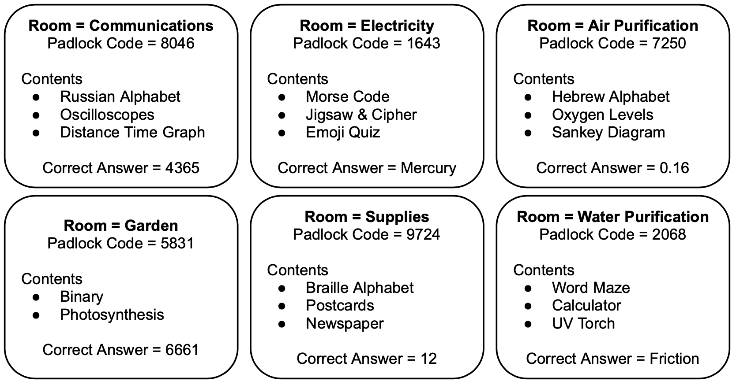

- Completing the Calendar. Simply write;
- “Amplitude” on the 1st January
- “Wavelength” on the 2nd January
- “Amplitude” on the 3rd January
- “Wavelength” on the 4th January

- Completing the Diary. On a random date write (suggestion 14/3 Einstein’s birthday);
“The correct clues are; (in normal ink)
- Oscilloscopes (in invisible ink)
- Jigsaw (in invisible ink)
- Oxygen Levels (in invisible ink)
- Photosynthesis (in invisible ink)
- Postcards (in invisible ink)
- Word Maze” (in invisible ink)

- Distribute the Resources. The resources in each locked box correspond to clues to the answer for that room, I suggest that each box is placed on its own table or distinct unique place. The diary, calendar, and countdown timer are placed at the front.

Delivery

The escape room is designed to be hands on and interactive, once the setup is complete there is minimal leader involvement. There is an optional presentation which talks about the actual possibilities of colonising Mars. This is an interesting topic which brings some reality to the activity and normally sparks interest but is not integral to the activity.

Colonisation of Mars – This PowerPoint explores the work being done by SpaceX in their mission to make Martian travel and colonisation possible. As well as asking students to thinking of the things crucial to creating a society on Mars.

Martian Escape Room User Interface – This is a presentation which allows the group to input their answers to check if they are correct. I recommend this being used once the group has all the answers, they believe to be correct, to prevent guessing, making sure they have solved all the problems.

Both PowerPoints are included with this pack, and have speaker notes to aid delivery.

Recommended Timetable

Activity | Duration | Notes
Escape Room | 40 minutes
Martian Escape Room User Interface | When the group think they have the correct answers | Gather the group at the front, to test their answers
Colonisation of Mars | 10 minutes | Instructor lead

Notes
- If the group is struggling, and they are running short on time feel free to provide them with hints, however from experience the less hints the better the student experience.
- The key to this escape room is there are codes, to get the keys which open the room (locked box). Then answers for the interface, which connect the room to electricity. Not all clues in the escape room contribute useful answers!

Worked Solutions

Communications
Clues | Solutions | Used For
Oscilloscopes  Uses;  - Calendar | Students must read the scale on the oscilloscope which states 1 square equal 1 horizontally but 1 square equal 2 vertically. Using the clue from the calendar they need to determine;  - The amplitude of the wave on oscilloscope 1 = 4  - The wavelength of the wave on oscilloscope 2 = 3  - The amplitude of the wave on oscilloscope 3 = 6  - The wavelength of the wave on oscilloscope 4 = 5  The correct answer is simply the four digits 4365 | Answer
Distance-Time Graph | Students must recall;  $$Speed= \frac{Distance}{Time}$$  To determine the speed between points C and D, they must read off the distance and time between C and D.  Distance between C and D = 4  Time between C and D = 2  Therefore, the speed is equal to;  $$Speed= \frac{4}{2}=2 m/s$$ | Nothing
Electricity
Clues | Solutions | Used For
Jigsaw & Cipher | Once the students have completed the jigsaw, they will be able to read the text on the jigsaw, instructing them to turn over. On the back of the jigsaw, they will see a code which assigns each letter of the alphabet a number. Using this they can decode the cipher to obtain;  Which planet has the shortest year?  The answer to which is Mercury, as is closest to the Sun. | Answer
Emoji Quiz | Students must determine what the emojis represent and use the word in place of the emoji. By adding, removing, or swapping letters as instructed students obtain;  What is the sixth planet from the Sun?  The answer to which is Saturn.  See below for more detailed solution. | Nothing
Air Purification
Clues | Solutions | Used For
Oxygen Levels | To answer the question on the card, students must add up the volumes of the gas to obtain 199.68 cm³ of other gases. This is then subtracted from the total volume (200 cm³), to obtain that there is 0.32 cm³ of oxygen in the Martian atmosphere. They must then calculate this as a percentage.  $$\frac{200-190-5.2-3.8-0.12-0.56}{200}=0.16 \%$$ | Answer
Sankey Diagram | Students must add up the contributions from water and air purification and then divide by the total input energy and multiply by 100 to obtain the value as a percentage.  $$\frac{840+840}{7000} x 100=24 \%$$ | Nothing
Garden
Clues | Solutions | Used For
Photosynthesis | Students must use assumed knowledge to determine the components of photosynthesis and then balance the equation to obtain;  6CO₂ + 6H₂0 → 6O₂ + 1C₆H₁₂O₆  The answer is then the prefactors to the components, as indicated by the clue, therefore 6661. | Answer
Supplies
Clues | Solutions | Used For
Postcards | Students must identify the correct postcard, there is one which stands out the Nice postcard. This is because all the other postcards have English cities on them, but Nice is French. From this they solve the resultant force diagram on the back of the Nice postcard.  Resultant Force = 20 – 8 = 12 N | Answer
Newspaper | Students need to read the article and determine the gravitational potential gained in climbing to the summit of Arsia Mons to the nearest million. Students must recall from assumed knowledge;  E_{GPE} = mgΔh  Using the information from the newspaper article;  - E_{GPE} = 896 x 3.72 x 9600 = 31997952  - E_{GPE} = 14,000,000 (to the nearest million) | Nothing
Water Purification
Clues | Solutions | Used For
Word Maze | Find the correct path through the word maze, students find;  When driving a car, the engine provides a force causing the vehicle to move forwards. What is the name of the force which the road surface provides which opposes this motion?  The answer to which is, friction. | Answer

Solved Jigsaw and Cipher Solution

Letter | Code Number | Letter | Code Number
A | 8 | N | 6
B | 18 | O | 26
C | 3 | P | 16
D | 23 | Q | 7
E | 13 | R | 17
F | 1 | S | 4
G | 21 | T | 24
H | 11 | U | 14
I | 5 | V | 10
J | 25 | W | 20
K | 15 | X | 2
L | 9 | Y | 22
M | 19 | Z | 12

If you are interested, the code is made by… Writing the German words for the numbers 1-26 and then alphabetising this list and assigning the alphabetised number to the letters in order. For example, the German for 8 is acht, which comes first alphabetically therefore 8 represents the letter A, and the German for 12 is zwolf which comes last alphabetically therefore 12 represents letter Z.
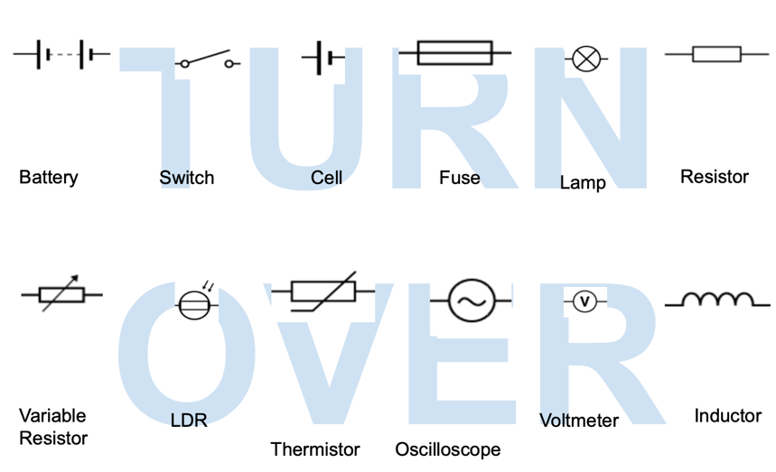
Detailed Emoji Quiz Solution

The emojis represent;

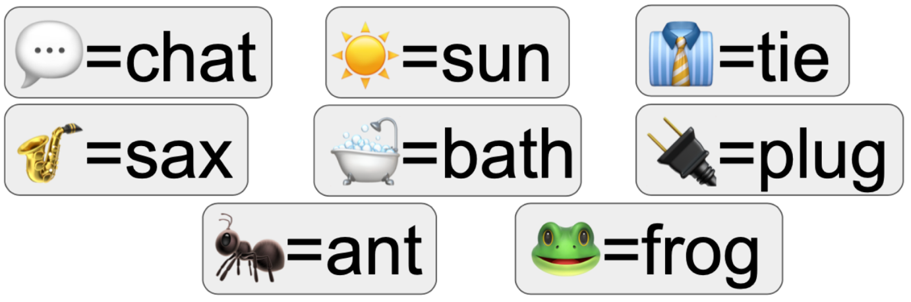

Substituting these into the initial clue;

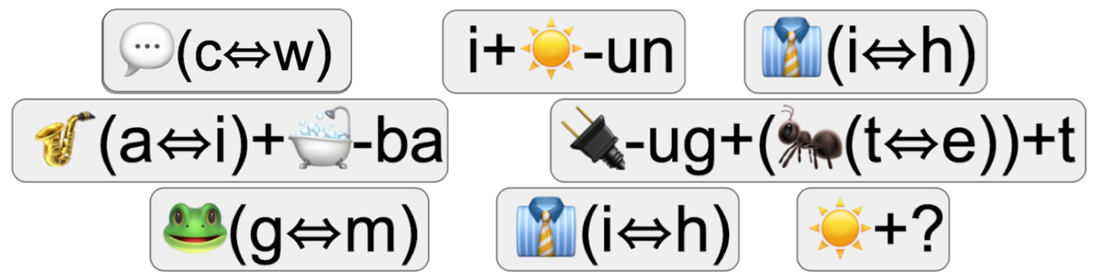

Chat(c⇔w) i+(sun-un) tie(i⇔h) sax(a⇔i)+bath-ba plug-ug+(ant(t⇔e))+t frog(g⇔m) tie(i⇔h) sun?

Chat, swapping the c with a w = What
I + (sun minus the un) = is
Tie swapping the I with a h = the
(Sax swapping the a with an I = six) + (bath minus the ba = th) = sixth
(Plug minus the ug = pl) + (ant swapping the t with an e = ane) + t = planet
Frog swapping the g with an m = from
Tie swapping the I with a h = the
Sun?

What is the sixth planet from the sun?

Common Pitfalls

There are a couple of common pitfalls I have listed them below to help you help your delivery if your group also fall victim to them. Note, that these are here to help you as opposed to steering the group away from these.

- Oscilloscopes – Often students forget to read the scale on the oscilloscopes, and incorrectly take 1 square vertically as 1 instead of 2. Some struggle to connect to oscilloscopes to the calendar, to which I encourage them to look at everything!
- Emoji Quiz – Some students struggle to correctly identify all the emojis, if this is the case, I provide clues to the correct emoji name.
- Oxygen Levels – Very common mistake, is to not read the question properly! Students always determine correctly that there is 0.32 cm³ of oxygen in Martian atmosphere but forget to convert this to a percentage as requested.
- Photosynthesis – Some students are confused about the prefactor of 1, when they have successfully balanced the rest of the equation.
- Postcards – Some students struggle to see the odd one out initially. To which I encourage them to look at everything and see what stands out!

Resources

Resources Checklist | \ \ | \ \ | \ \ | \ \ | \ \
Oscilloscopes*
Distance-Time Graph*
Jigsaw*
Cipher*
Emoji Quiz*
Oxygen Levels*
Sankey Diagram*
Photosynthesis*
Postcards*
Newspaper*
Word Maze*
Russian Alphabet
Morse Code
Hebrew Alphabet
Binary
Braille Alphabet
Emergency Shutdown Protocol Booklet (2 pages)

*These resources go into locked boxes.

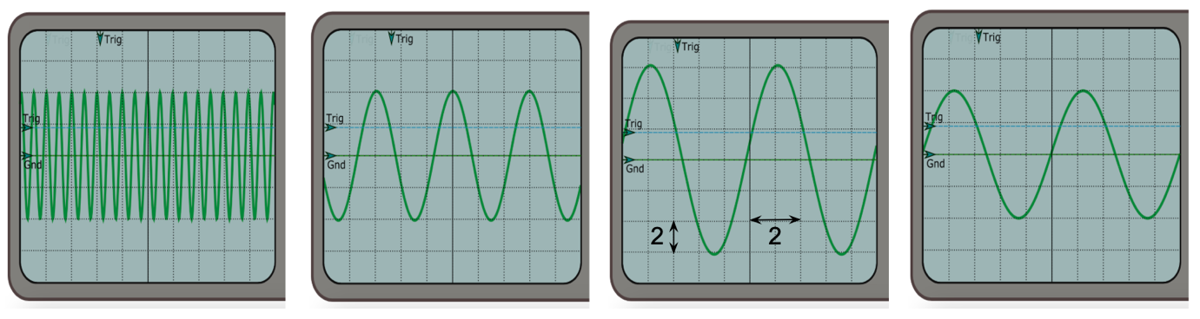

Oscilloscopes

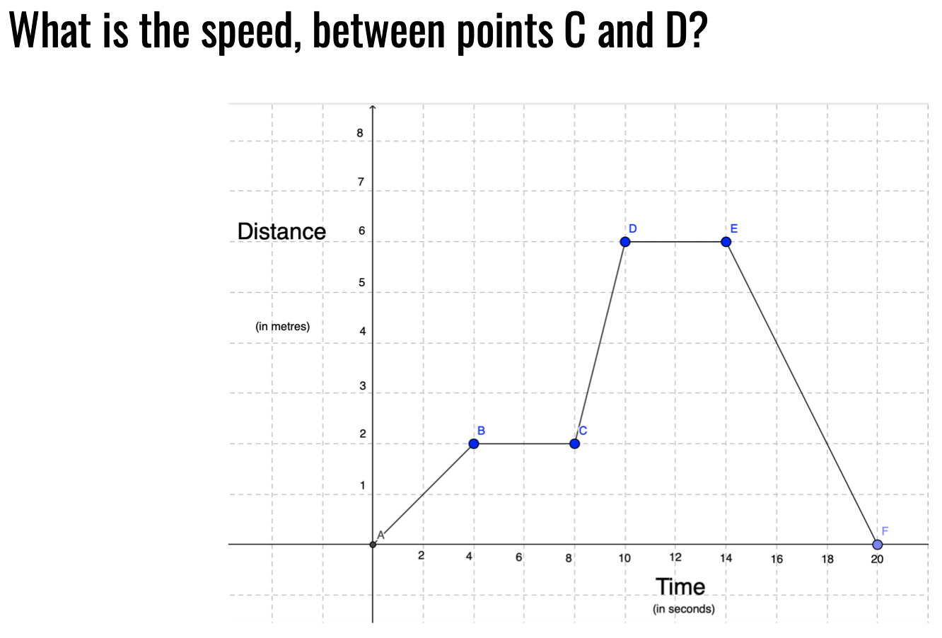

Distance-Time Graph

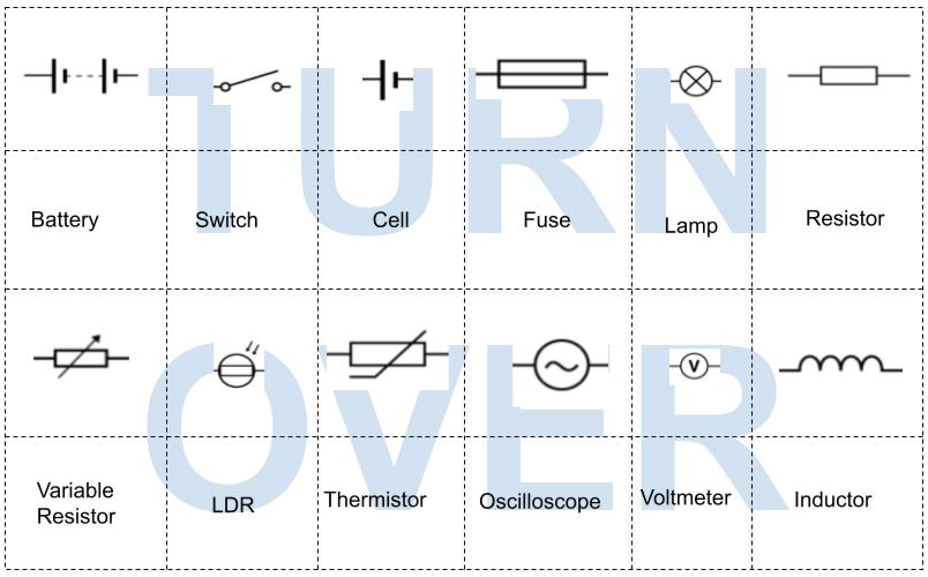

Jigsaw

Cipher

Emoji Quiz

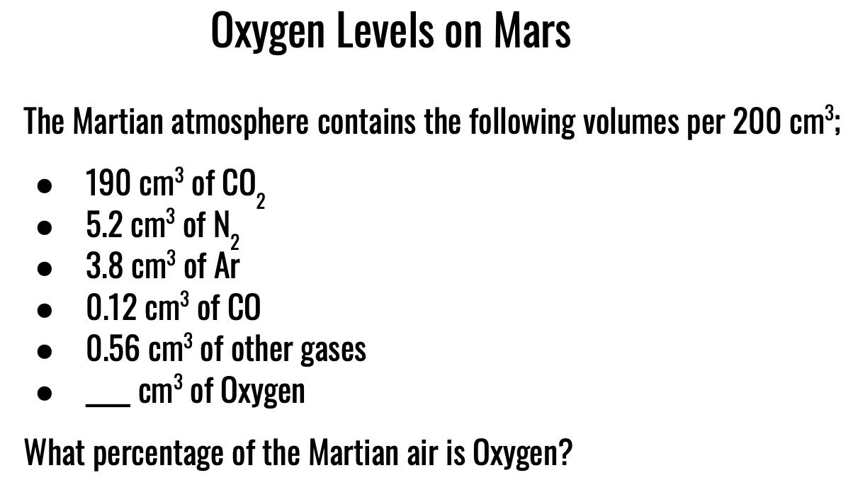

Oxygen Levels

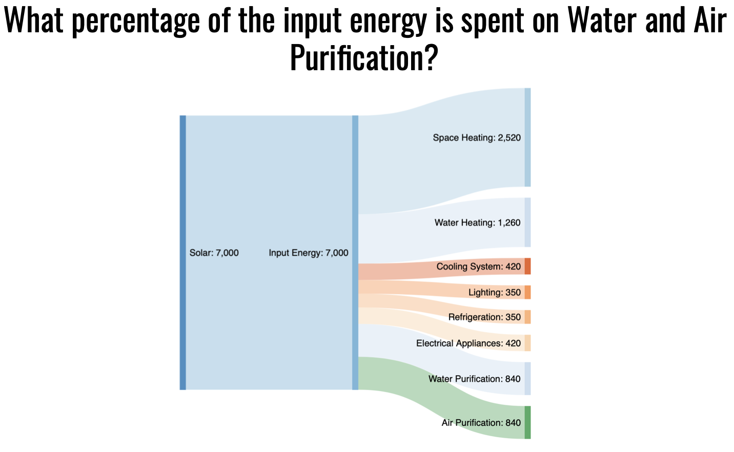

Sankey Diagram

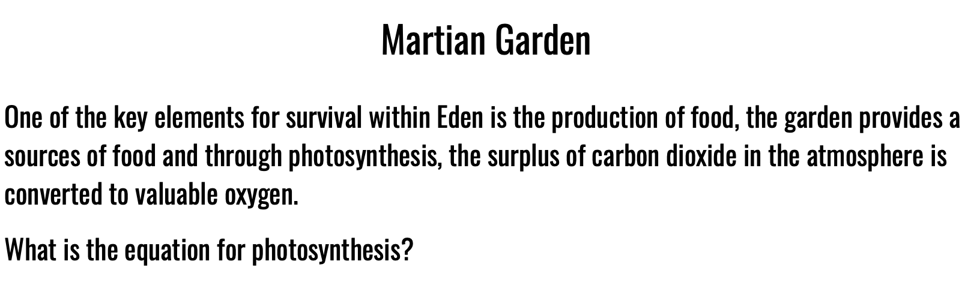

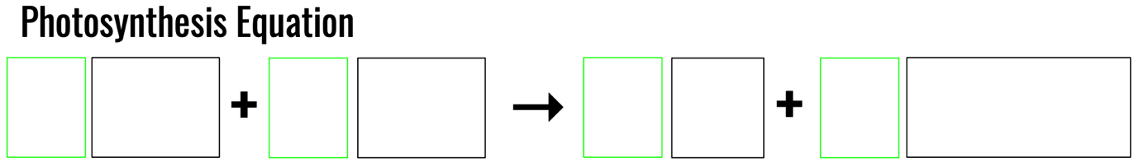

Photosynthesis

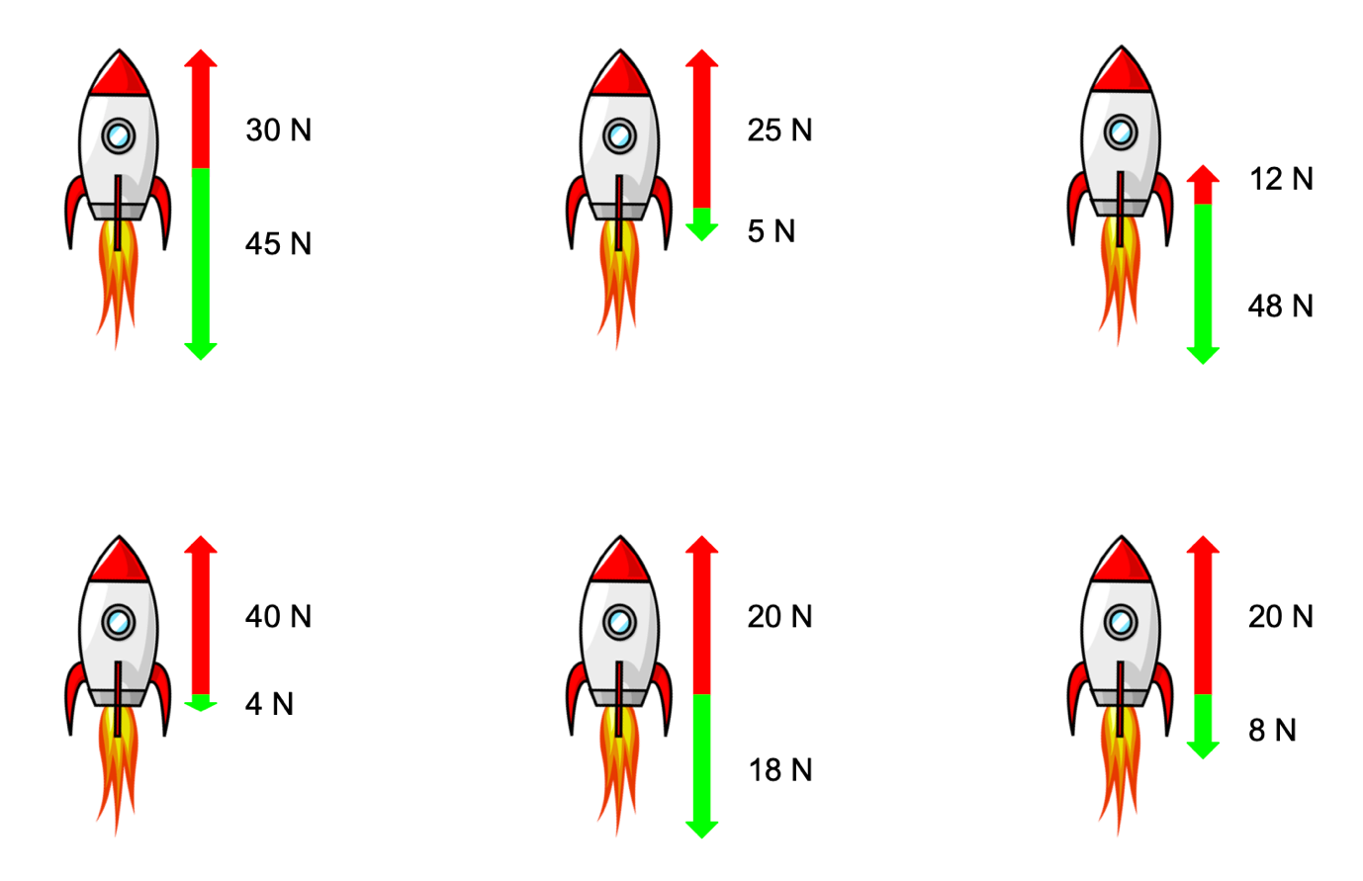

Postcards

The rockets should be printed on the reverse of the postcards, it does not matter which is on which apart from the 20 N and 8 N rocket must be on the back of the Nice postcard.

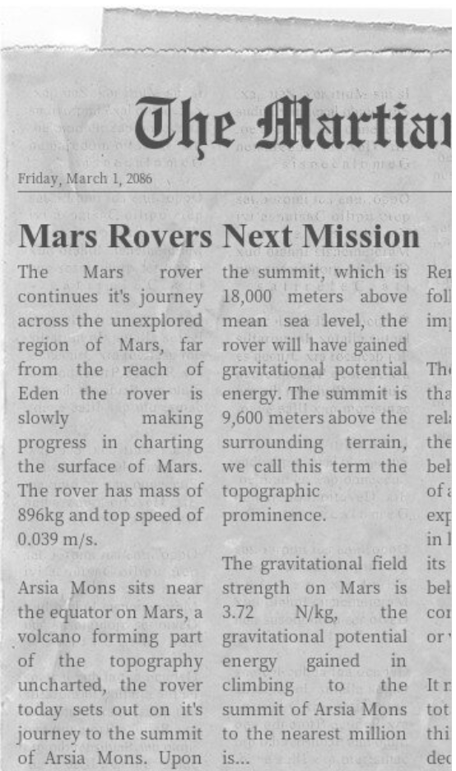

Newspaper

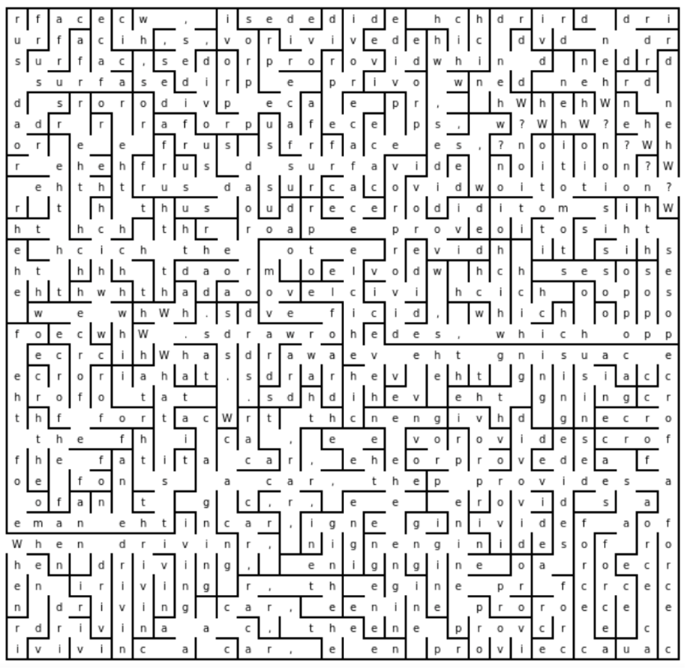

Word Maze

Emergency Protocol Handbook

In the event of a power outage, all interconnecting doors will automatically lock, to prevent the contamination of the air inside Eden. To gain access to the pods, enter the following codes, only do so if the area you are about to enter has a breathable atmosphere.

!Proceed with Caution!

Emergency Door Codes

Communications: Eight Zero Four Six

Electricity: один шесть четыре три

Air Purification: --... ..--- ….. -----
Water Purification:

Garden: אחת שלוש שמונה חמש

Supply Pod: 1001 111 10 100

To prevent improper use the codes are written in a series of codes and languages (known by officials on Eden) if officials are not available in an emergency the codes are detailed in this handbook.

Morse Code

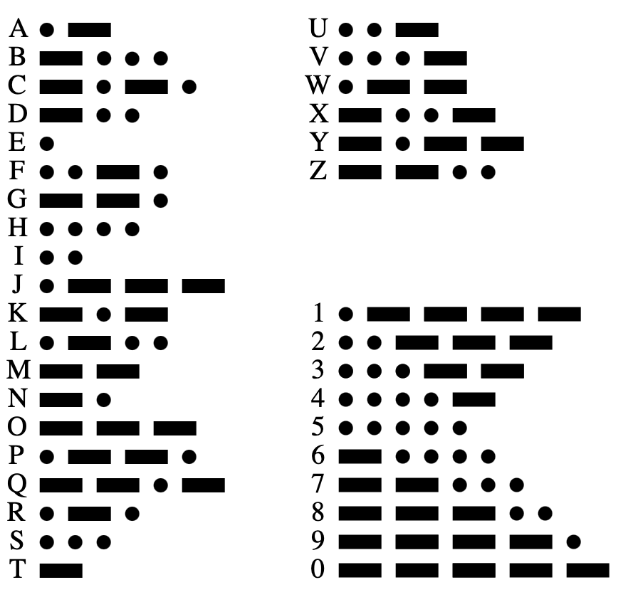

Braille

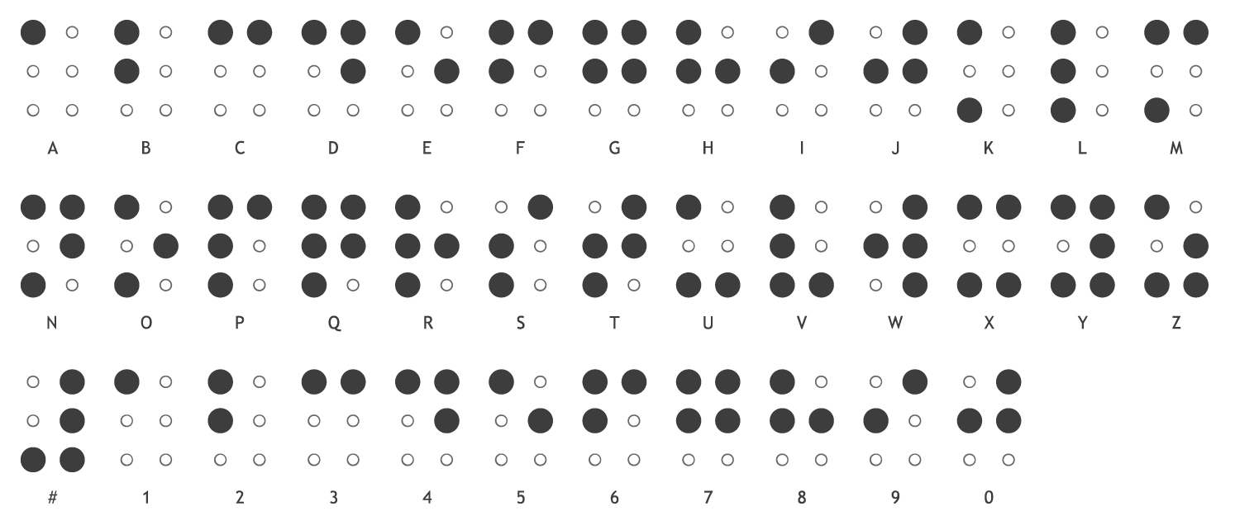

Russian Alphabet

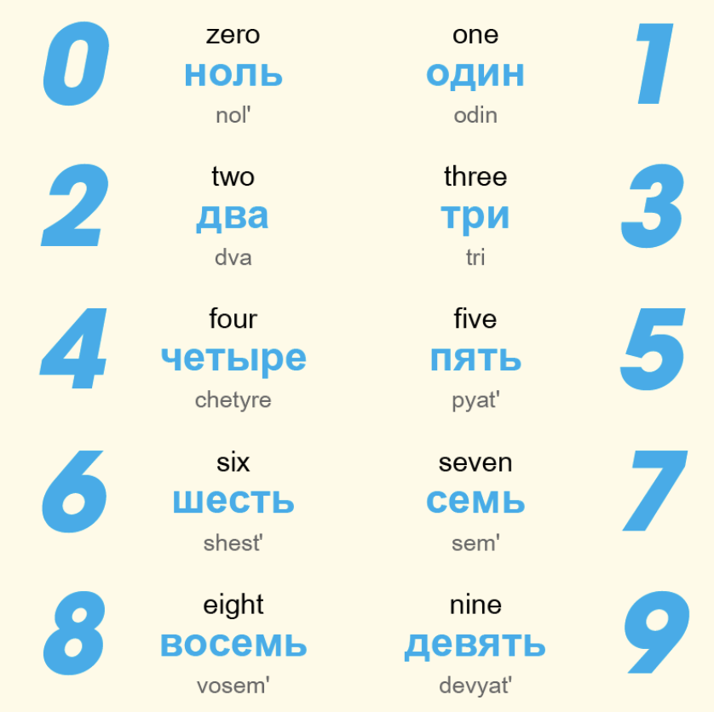

Hebrew Alphabet

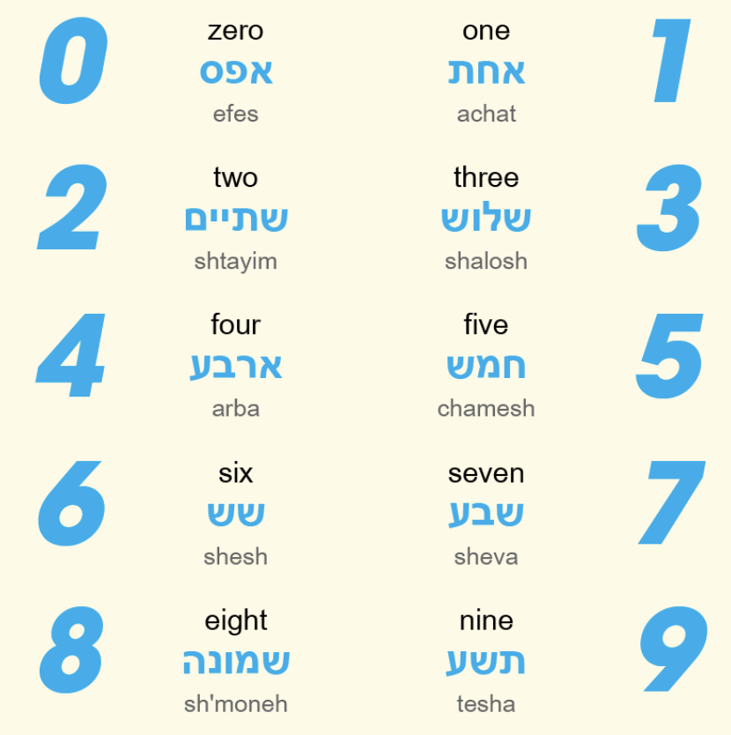

Binary

0 = 0

1 = 1

2 = 10

3 = 01

4 = 100

5 = 101

6 = 110

7 = 111

8 = 1000

9 = 1001

Physical Props Recommendations

Item | Quantity | Price per Item | Total Price | Amazon Link
Padlocks  (Pack of 2) | 3 | 8.99 | 36.97 | https://www.amazon.co.uk/dp/B07GRRKZQ2/?coliid=I2CGNV9G22HPHS&colid=38E2CUXS21XYG&psc=1&ref_=lv_ov_lig_dp_it
Locked Box (Key) | 6 | 9.99 | 59.94 | https://www.amazon.co.uk/dp/B00TY2O8QC/?coliid=I3K30G5TI5DY63&colid=38E2CUXS21XYG&psc=1&ref_=lv_ov_lig_dp_it
UV Torch | 1 | 7.99 | 7.99 | https://www.amazon.co.uk/Ultraviolet-Flashlight-Blacklight-Detector-Batteries/dp/B00GU55270/ref=dp_prsubs_2?pd_rd_i=B00GU55270&psc=1
Diary | 1 | 1.99 | 1.99 | https://www.amazon.co.uk/2022-Hard-Cover-Diary-Burgundy/dp/B0995SWRZG/ref=dp_fod_1?pd_rd_i=B0995SWRZG&psc=1
Invisible Ink Pens | 1 | 6.98 | 6.98 | https://www.amazon.co.uk/dp/B078876V8M/?coliid=I1BANKTZNX2IKT&colid=38E2CUXS21XYG&psc=1&ref_=lv_ov_lig_dp_it
Calendar | 1 | 2.99 | 2.99 | https://www.amazon.co.uk/Planner-Calendar-Commercial-Office-Student/dp/B07WK86NKX/ref=sr_1_17?crid=3M2FKFMEUQNFP&keywords=calendar+cheap&qid=1646348359&sprefix=calendar+cheap%2Caps%2C72&sr=8-17
Total Price |  |  |  | £116.86
Optional Extras
Traffic Light Timer | 1 | 30.99 | 30.99 | https://www.amazon.co.uk/dp/B0007DHU0S/?coliid=I2YPLVH0SJOAMS&colid=38E2CUXS21XYG&psc=1&ref_=lv_ov_lig_dp_it
Pocket Calculator | 1 | 3.29 | 3.29 | https://www.amazon.co.uk/dp/B00BE1I6AK/?coliid=IVFOYXXXG1BZL&colid=38E2CUXS21XYG&psc=1&ref_=lv_ov_lig_dp_it
Total Price |  |  |  | £34.28

Note for Physical Props: Items may become unavailable and/or prices may vary. These are simply suggestions; alternatives will be available which can prove just as effective. Please use this as a guide to the items you purchase.

